Date: May 19, 2022
To: Weber County Board of County Commissioners

From: Ronna Tidwell
Community Development Department

Agenda Date: May 24, 2021

Subject: Request to Declare Parcel Number 04-022-0016 as Surplus Property

Attachments: A - Aerial View of Parcel
B - Recorder’s Plat

_____________________________________________________________________________________

Summary:
A Weber County owned parcel of land, identified as Tax ID #04-022-0016, was acquired by the County through a tax sale process and deed executed in 1994 The parcel contains approximately 1,841 square feet and is located at 3076 Ogden Ave.
The County has been contacted by an adjacent property owner and was asked if the County would consider selling the subject parcel.
Weber County has no intended use for this property; therefore, it can be declared surplus and offered to an interested buyer. In order to convey real property, the County Commission must first take action to declare this parcel as surplus property.

Property Description:
04-022-0016
PART OF LOTS 7 AND 8, BLOCK 6, WOODMANSEE'S MAIN STREET ADDITION, OGDEN CITY, WEBER COUNTY, UTAH: BEGINNING AT A POINT 39.5 FEET SOUTH OF THE NORTHWEST CORNER OF SAID LOT 8, RUNNING THENCE SOUTH 26.5 FEET; THENCE EAST 62 FEET;THENCE NORTH 15.5 FEET; THENCE EAST 18 FEET; THENCE NORTH 11FEET; THENCE WEST 80 FEET TO THE PLACE OF BEGINNING. ALSO: GRANTING A RIGHT-OF-WAY IN COMMON WITH OTHERS OVER THE FOLLOWING DESCRIBED TRACT OF LAND: BEGINNING AT A POINT 39.5 FEET SOUTH OF THE NORTHWEST CORNER OF SAID LOT 8, RUNNING THENCE EAST 80 FEET; THENCE NORTH 8 FEET; THENCE WEST 80 FEET; THENCE SOUTH 8 FEET TO THE PLACE OF BEGINNING..
Attachment A

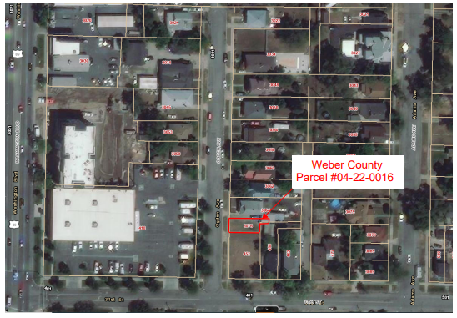
Attachment B
